**This page is for indexing. Please complete for each author.**

For additional details please see the [ASABE Guide for Authors.](http://www.asabe.org/media/59251/asabe_guide_for_authors.pdf)

Author

|  |  |  |  |  |  |
| --- | --- | --- | --- | --- | --- |
| First Name or initial | Middle Name or initial | Surname | Role (ASABE member, professor, etc.) | E-mail (and phone for contact author) | Contact  author?  yes or no |
| Trevor | P | Stanhope | ASABE Member | Trevor.stanhope@mail.mcgill.ca | no |

Affiliation

|  |  |  |  |
| --- | --- | --- | --- |
| Organization | Address | Country | URL or other info. |
| McGill University | 21111 Lakeshore Road, Sainte-Anne-de-Bellevue, QC | Canada |  |

Author *(repeat Author and Affiliation tables for each author)*

|  |  |  |  |  |  |
| --- | --- | --- | --- | --- | --- |
| First Name or initial | Middle Name or initial | Surname | Role (ASABE member, professor, etc.) | E-mail (and phone for contact author) | Contact  author?  yes or no |
| Viacheslav | I | Adamchuk | Professor | Viacheslav.adamchuk@mcgill.ca | yes |

Affiliation

|  |  |  |  |
| --- | --- | --- | --- |
| Organization | Address | Country | URL or other info. |
| McGill University | 21111 Lakeshore Road, Sainte-Anne-de-Bellevue, QC | Canada |  |

Author *(repeat Author and Affiliation tables for each author)*

|  |  |  |  |  |  |
| --- | --- | --- | --- | --- | --- |
| First Name or initial | Middle Name or initial | Surname | Role (ASABE member, professor, etc.) | E-mail (and phone for contact author) | Contact  author?  yes or no |
| Jofroi |  | Desperrier-Roux | Professor | jofroi@agri-fusion.com | no |

Affiliation

|  |  |  |  |
| --- | --- | --- | --- |
| Organization | Address | Country | URL or other info. |
| Agri-Fusion 2000, Inc. | 481 Chemin St-Philippe, St-Polycarpe, QC | Canada |  |

A Low-cost system for integrating computer-vision guidance with inter-row cultivation

T. P. Stanhope, V. I. Adamchuk, J. Desperrier-Roux

The authors are **Trevor P. Stanhope**, ASABE Member, Graduate Student, and **Dr. Viacheslav Adamchuk, Associate Professor**, Department of Bioresource Engineering, McGill University, Sainte-Anne-de-Bellevue, QC, Canada. **Corresponding author:** Dr. Viacheslav Adamchuk, McGill University, 21111 Lakeshore Road, Sainte-Anne-de-Bellevue, Quebec, Canada; phone: 514-398-7657; e-mail: viacheslav.adamchuk@mcgill.ca.

**Abstract.**

Management of organic row crops requires frequent in-field operations. Depending on the degree of soil conservation practices, weed control necessitates tillage operations. Strip-tillage and cultivator implements require precise guidance systems to assure proper positioning of the working tools. Legacy systems have made use of mechanical guiding rods, however such systems perform poorly during the earliest stages of crop growth. Modern techniques based on RTK GPS are available commercially but are prohibitively expensive for small-scale operations. Therefore, the objective of this study was to develop a low-cost CCD camera system which is capable of supplementing the mechanical row detection during inter-row cultivation. A computer-vision guidance system was developed for the Intel Atom architecture to interface with an electro-hydraulic steering hitch system. Two redundant CCD cameras were mounted to the cultivator tool-bar in-line with crop rows to obtain a video stream of the plants passing beneath the implement. The OpenCV platform was used to develop an algorithm for identifying the lateral offset of the plant rows and adjust the hydraulic steering accordingly via PID control. The computer-vision guidance system was tested successfully without GPS RTK assistance at travel speeds of 6, 8, 10, and 12 km/h in corn and soybean fields under varying ambient light and crop conditions.

**Keywords.**

Computer-vision, inter-row cultivation, control systems, hydraulic steering, implement guidance

# Introduction

Unlike conventional farming where herbicide application is the primary method for weed prevention, organic farmers must use tillage implements such as inter-row cultivators. Inter-row cultivation is a field operation which requires precise control of the implement in order to maximize the tillage area without causing damage to the crops. Cultivation is often conducted at speeds of up to 12 km/h with an error tolerance of only ±5 cm. Although many organic farmers are equipped with RTK-level global navigation satellite systems (GNSS) for tractor steering, such systems are uncommon and expensive for guiding tillage implements. As such, many farmers prefer to use older, mechanically-guided tillage systems. A common method for mechanically-guided cultivators employs guiding rods (also known as brushes) which are mounted to a rotating voltage divider (Figure 1). These rods make contact with the crop stems and their position approximates that of the crop row. The resulting reference signal is fed to a hydraulic control system which adjusts the steering mechanism of the implement accordingly. Although these mechanically-guided systems are rugged and maintainable, the guiding rods perform poorly with seedlings. During the early stages of growth (e.g. < 15 cm), guiding rods have the potential to cause damage to the crop or lose track of the row, forcing operators to travel at speeds of less than 6 km/h. To address this issue, modern systems implement non-contact detection methods, such as a secondary RTK GNSS antennae or cameras, to estimate the lateral offset of the cultivator.

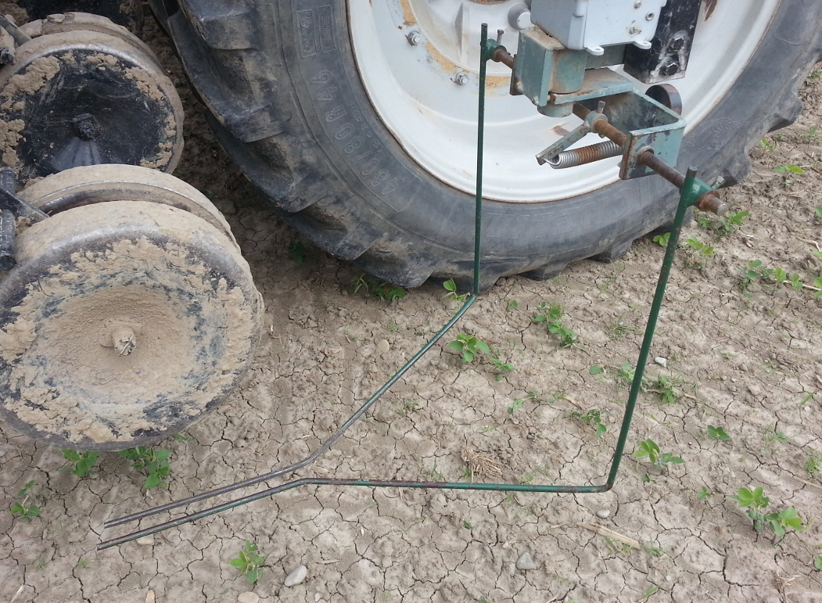

Figure 1. Mechanical guiding rods.

Demand for high-precision tractor control has produced significant research interest over the past two decades. In addition to advances in global navigation satellite system (GNSS) guidance systems, research has demonstrated that mechanical and computer-vision systems can be implemented to detect the lateral offset of the crop rows relative to the tractor/implement with a high degree of reliability and accuracy (Tillett, 1991). By integrating computer-vision systems into agricultural platforms, the precision of field operations can be improved. Research applications of computer-vision row detection have demonstrated that computer-vision guidance systems can be an effective approach for feedback and control of agricultural implements. Several different computer-vision methodologies have been proposed for identifying the position of the crop rows, including stereo-vision, Hough Line Transform, multi-spectral imaging, and band-pass analysis, among others. A common challenge faced by computer-vision systems is the determination of the distribution of plant foliage within the captured images and the subsequent differentiation between the crop row and soil/weeds, a process known as segmentation (Brivot, 1996).

With respect to the segmentation of green vegetation (e.g. for crop-row tracking or weed detection), a significant amount of research has been focused on developing robust color indices. Using unfiltered RGB data from CCD/CMOS cameras is not employed due to the high correlation between the three color channels. Research has shown that imaging a combination of bands in the visible and infra-red spectrum produces reliable results (Slaughter, 2008), however this requires specialized camera systems. Therefore, when using RGB imaging systems conversion to an alternate color index is advantageous for plant segmentation. Crop-specific color indices have been developed for agricultural application, such as Excess Green (ExG) (Woebbecke, 1995) and Vegetative index (VEG) (Hague, 2006), while standard indices such Hue-Saturation-Value (HSV) have also seen implementation (Moorthy, 2015).

During the process of crop detection, varying ambient light is one of the major limiting factors for successfully implementing computer-vision guidance for weed control. Variations in the ambient light occur naturally with changes in weather and time of day, and can dramatically change the appearance of crop foliage, e.g. texture and color, in a digital image. Additionally, non-uniform lighting intensity, e.g. shadows, are also a major concern. Non-uniform lighting results in irregular variance in the intensity of pixels and thus increases the complexity of segmenting plants using color indices.

Therefore, a necessary component of any robust segmentation algorithm is the proper selection of threshold values to binarize the color-index image. Thresholding techniques proposed to segment crop images include dynamic thresholding methods (Rovira, 2005), Otsu-based thresholding methods (Meyer, 2008) and statistical mean-based segmentation of the image (Guijarro, 2011). Although functional, these methods generally assume the histogram of the image to be bimodal and require the vegetation and background to belong to two different brightness regions.

Although thresholding reduces errors due to varying ambient lighting, typically such methods experience reduced performance due to non-uniform illumination conditions. In recent years, research has been carried out on developing complex, yet efficient, algorithms for vegetation segmentation. Examples of such techniques include mean-shift-based learning procedure (Zheng, 2009), Environmentally Adaptive Segmentation Algorithm (EASA) (Tian, 1998), and a Naive Bayes learner using HSV, G-R and normalized RGB (Moorthy, 2015).

After segmentation of the plants within the image, it is necessary to determine the lateral offset of the crop row. Methods for determining the lateral offset can be grouped into two classes based on whether the camera’s angle of inclination is either equal to zero, or greater than zero; these classes are referred to as orthogonal or perspective, respectfully.

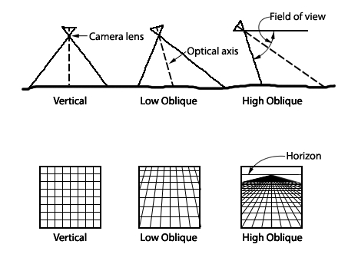

Figure 2: Perspective vs. orthogonal viewing angles (Wolf, 2000).

Orthogonal methods rely on a camera which faces vertically downward and is directly aligned with a single crop row of the cultivator. A basic approach proposed by Olsen et al. in 1995 for detecting the lateral offset of the crop relies on taking the sum of the pixel elements gray values in the direction of travel. The resulting curve represents the likelihood of the row’s position for each x-index within the image. To isolate the most probable offset, two separate methods were compared: 1) a least squares regression of a sinusoidal wave, and 2) a Fourier Fast Transform (FFT) low-pass filter. Both filtration methods were effective in cereals to within an error of 10 mm, but performed poorly on sugar beets due to their characteristically large leaf volume. In a similar study by (Slaughter, 1997), an algorithm for detecting the lateral offset of the row using individual segmentation of plants in the image was proposed. For each plant, a histogram of the intensities was calculated which was then used to find the median offset of each plant. If a plant’s median was significantly different than the other plants in the image, it was considered a weed and disregarded. The row offset was then calculated based on the medians of the remaining plants. This method was tested on lettuce and tomatoes for use with a band sprayer operating at 8 km/h and performed successfully with standard error of 9 mm and within 12 mm 95 percent of the time.

Conversely, perspective methods rely on a camera with a positive angle of inclination with multiple rows in the field of view. One approach for perspective guidance utilizes the Hough Line Transform (HLT) algorithm to detect linear rows in cauliflower, sugar beets, and wide-spaced wheat. In a study by (Pla, 1997), a system using HLT performed with an error of 18 mm, which was considered sufficient by the researchers. A similar perspective approach using a band-pass filter proposed by (Hague, 2001) based on prior knowledge of the spacing of the crop rows was developed for use on cereals and beets. Supported by the British Beet Research Organization the developed system was capable of 3 cm precision at speeds of up to 10 km/h. The project was considered highly successful and was commercialized in 2001 in partnership with Garford Farm Machinery and Robodome Electronics under the name RoboCrop.

When comparing the orthogonal and perspective methods, both have advantages and disadvantages. The perspective approach is less sensitive to missing plants and high weed density due to the greater field of view. However, perspective methods rely on prior knowledge of the crop spacing and linear rows with low curvature. Comparatively, orthogonal systems optimize resolution, in pixels-per-centimeter, and require only basic calibration. Conversely, lens distortion is an issue for perspective systems due to the greater subject distance and orientation of the camera. To compensate for increased subject distance, perspective methods require a higher resolution camera, resulting in greater computational requirements and costs. The reduced field of view for orthogonal systems is a concern when there are significant gaps in the crop rows. To address the issues inherent to the orthogonal approach, a system with two or more cameras may provide sufficient redundancy and cameras can be oriented width-wise to the crop row to increase the effective field of view along the direction of travel (Slaughter, 1995).

Actuation of a cultivator implement can be achieved by several methods, such as vehicular steering, pivoting hitches, side-shift hitches, or stabilizer steering. Of these, vehicular steering has received tremendous interest, however due to the soil forces acting on separate mechanics affect the implements position relative to the vehicle and therefore solely relying on vehicular steering is not applicable in all environments. Actuated hitch systems, such as disc-steer and side-shift systems, have also seen commercial success. For light cultivation, both disc-steer and side-shift style control has been demonstrated to be effective at speeds < 8 km/h and on flat terrain (Kocher, 2000). However, side-shift systems have been observed to cause problems when the implement is configured for heavier cultivation (e.g. deep harrows or coulters) due to “jumping”, i.e. the effect of the hitch shifting the tractor. To address this problem either requires either removing tools or dramatically increasing the weight of the tractor, both of which are undesirable to the farmer. Alternatively, disc-steer systems are steered by adjusting the radial position of the cultivator discs, thus affecting the amount of lateral force caused by soil resistance. Due to the simpler of mechanism for adjusting the travel of the implement, disc-steer platforms, such as pivoting-hitch or rotating-stabilizer systems, are often preferred by farmers for deeper cultivation practices (Desperrier 2014). However, disc-steer systems can suffer in performance in very sandy soils (CITATION). A disc-steer hydraulic hitch positional control system can be simplified as a linear system. The output is the lateral error of the vehicle relative to the crop row and the input is the position of the steering mechanism. Additionally, state-information of the system is required, and it is assumed the angular speed is constant and travel speed is within acceptable bounds.

The **objective** of this study was to develop a low-cost embedded system which extends computer-vision row detection functionality to existing electro-hydraulic implement guidance systems. To be considered effective for commercial use, such a guidance system must be capable of 4 cm precision 95 percent of the time for travel speeds up to 12 km/h and for crops up to 20 cm in height.

# Materials and Methods

For field evaluation, a twelve row Hiniker cultivator equipped with a Sukup Auto-Guidance system mounted to a Fendt Vario 850 was used throughout the testing period. The cultivator tool-bar was configured to a row-spacing of 30 inches. The computer-vision guidance system was installed alongside the existing mechanical guidance system to act as a replacement for the guiding rod potentiometer.

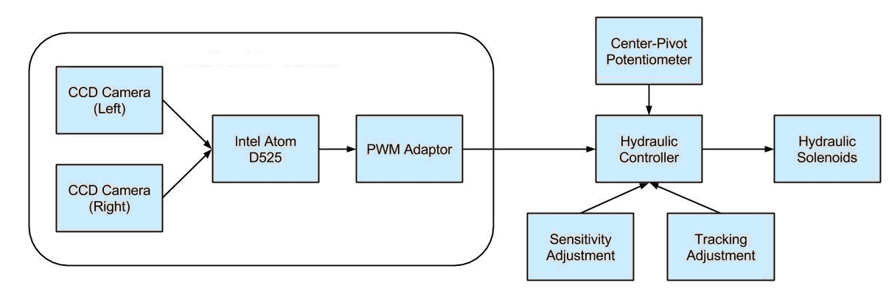

Figure 3: Diagram of the computer-vision system integrated with hydraulic controller.

The remaining components of the Sukup Auto-Guide system, including the electro-hydraulic controller, center-pivot potentiometer, manual adjustment inputs, and hydraulic solenoids, were unmodified. This configuration allowed easily switching between the two modes of operation during field trials. Images of the plants passing beneath the cultivator are captured by two weather-proof CCD cameras mounted via C-brackets to he tool-bar. In a compromise between the orthogonal and perspective methods, the two cameras were mounted at a low-oblique perspective of 30° inclination from vertical and a subject depth of 1.0 m. This approach provides additional longitudinal field of view without contributing to lateral image distortion. To provide row estimation redundancy in the event of regions of high weed density or gaps in the crop rows, the two cameras were installed on the 3rd and 9th rows of the cultivator tool-bar.

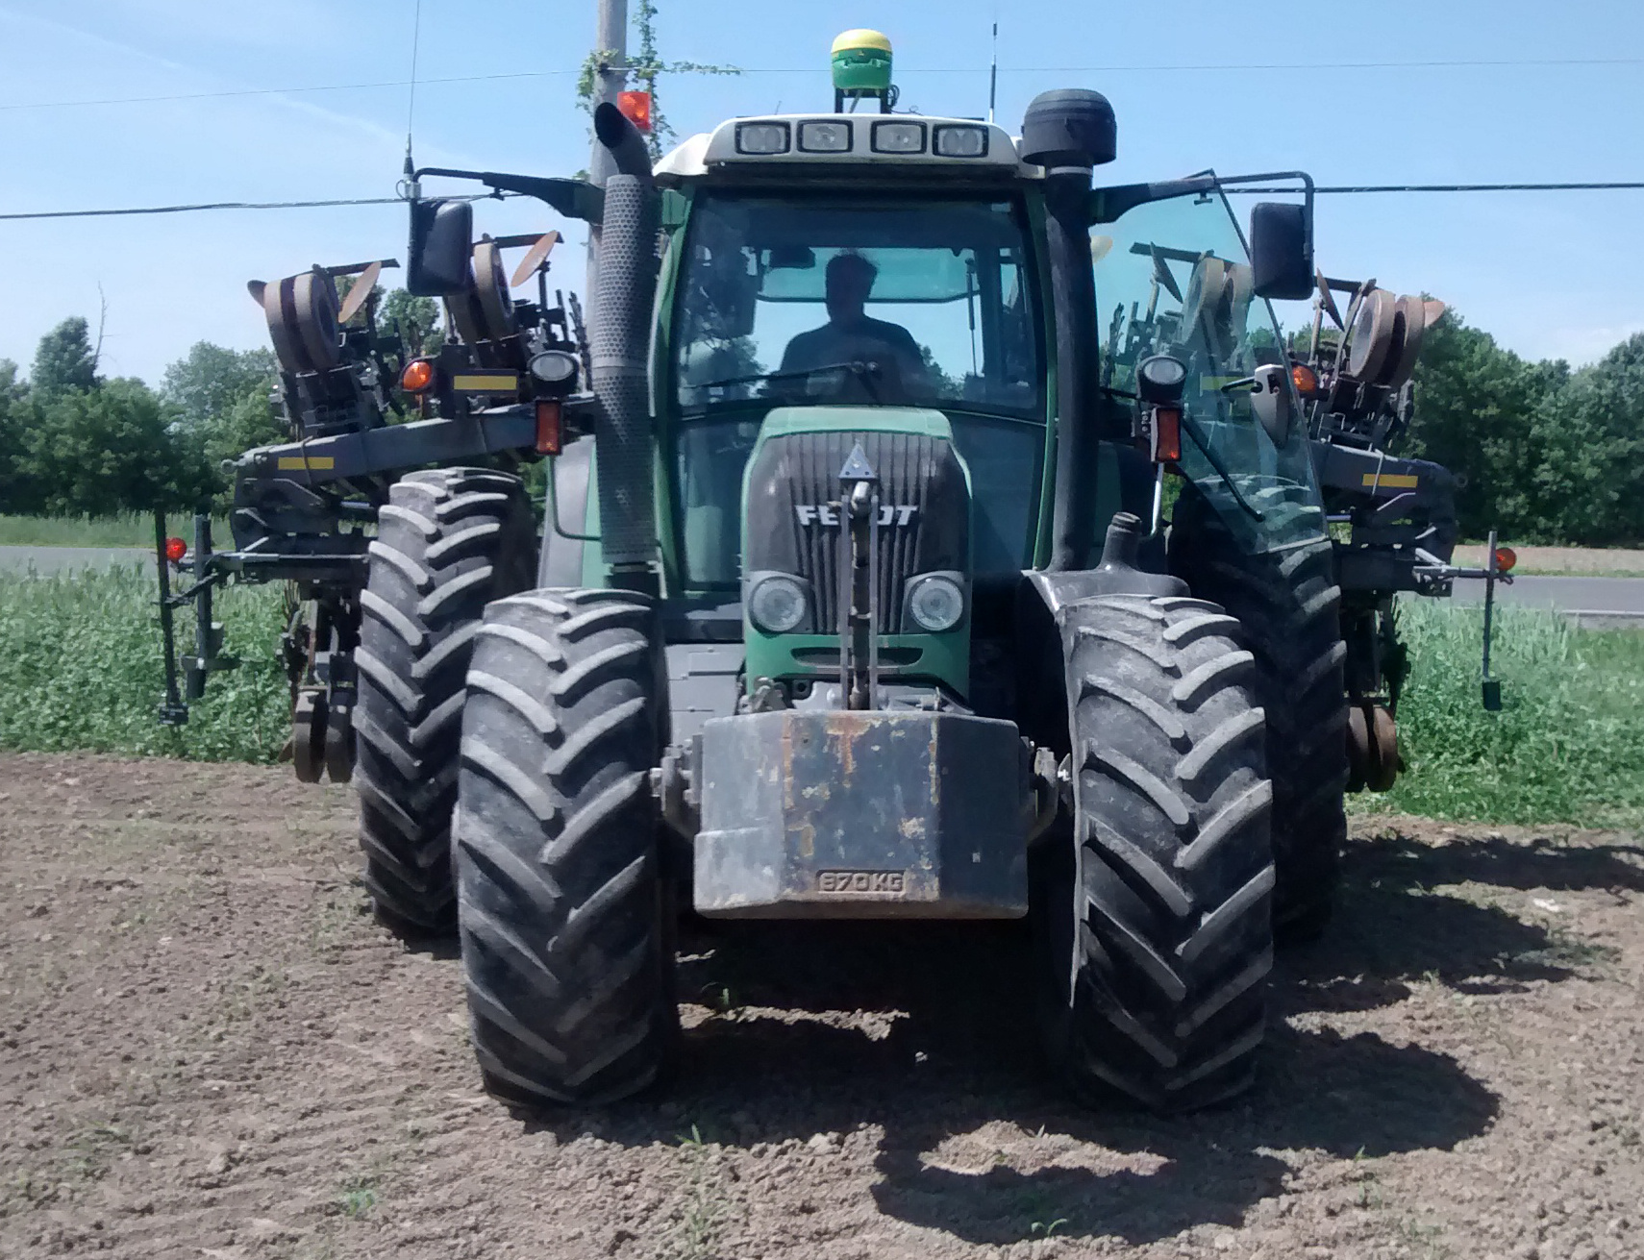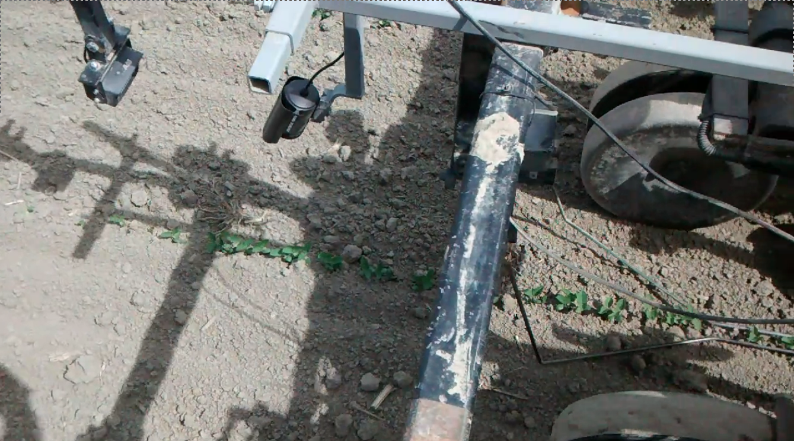

Figure 4. Test tractor and mounting system for camera and guiding rods.

An embedded Linux system based on the Debian 7.8 operating system (Linux Kernel 3.2) was developed for the Intel Atom D525 architecture. A 1.8GHz processor was used, with a 32 GB SSD, and 1 GB of RAM (Jetway). A run-time application was developed for the system using the Python programming language (v. 2.7.6) which operated as a local microwebserver. A high-speed database server (MongoDB 32-bit) was implemented for ultra-low latency storage and retrieval of data. This robust platform provided sufficient computing power for real-time image analysis at a relatively low cost. To generate the output voltage signal of the control system, an ATmega328P micro-controller was implemented as an 8-bit PWM generator. The micro-controller was integrated as a Universal Serial Bus (USB) peripheral device with the microprocessor serving as the host. Lastly, a graphical user interface was developed in order to provide a live video feed for the operator.

## Plant Segmentation

Images of the crop rows were captured in real-time from two CCD cameras. The cameras used for this study had a native resolution and frame-rate of 640x480 and 25 frames-per-second, respectively. However, were hardware downscaled to a resolution of 320x240 and 16 frames-per-second. After capturing an image, the image matrix was transformed from the Red-Green-Blue (RGB) color-space to the decorrelated Hue-Saturation-Value (HSV) color-space in order to simplify band-pass filtering operations:

 (1)

 (2)

 (3)

After transforming the image to the HSV color-space, a band-pass plant detection filter (BPPD) was applied to isolate pixels which could represent plant foliage. This filter selects for pixels with hue ranging from yellow-green to blue-green, saturation above the mean saturation, and value (i.e. brightness) between the extremes of under- and over-exposed. Threshold values were determined empirically using a training set of sample images in varying light and crop conditions. During this process, it was observed that the cameras experienced significant blue-shifting of crop foliage in very bright or low light, so the upper threshold for hue was set well into the cyan-blue region. This change did not have any noticeable negative impact on performance due to the relative lack of blue-tones in soil.



where n is the percentile of the sorted array A of C of length N. (4)



where Hmin = 45 (yellow-green), Hmax = 105 (blue-green). (5)

The BPPD filter utilizes the linear interpolation percentile function to calculate the upper and lower thresholds of the Value and Saturation bands. This approach eliminates the need for static limits, reducing false-positive classification of pixels as green under varying lighting conditions. As a final post-processing step, morphological opening with a 3 by 3 kernel was applied to the BPPD mask to reduce any remaining noise while preserving the structure of crop foliage. This three step process was found to be computationally non-intensive, yet produced sufficient segmentation in diverse lighting conditions. Notably, the percentile-based band-pass filters of saturation and intensity produced reliable masks in the worst-case scenarios of poor exposure and shadows.

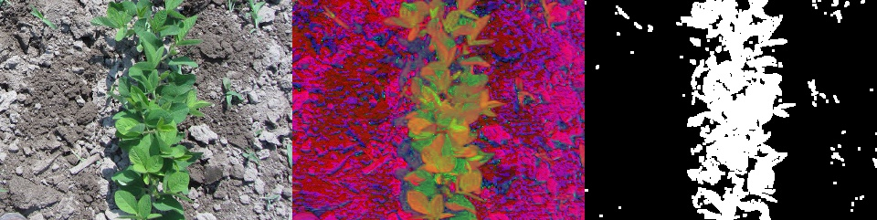

Figure 5. BPPD algorithm applied to image with diffuse lighting.

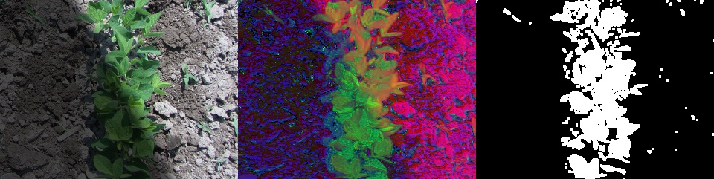

Figure 6. BPPD algorithm applied to image with non-uniform lighting.

## Row Estimation

After the plant foliage mask (BPPD) has been produced, the column summation of the mask was calculated in the direction of travel, resulting in an array (C) representing the lateral distribution of plant foliage within the image (Equation #). Indices of the C-array with low values suggest bare-soil, moderate values suggest sparsely distributed weeds, and higher values suggest presence of the crop row due to the longitudinal alignment of the plant foliage. Using this distribution, the centroid of the crop row was estimated by applying a high-pass filter to select for indices which are significantly greater than others:

 (7)

 (8)

where α = 0.95, H is the height of the image (pixels).

The resulting array (p) consists of all indices of the image which are most likely to represent the crop row. The estimated centroid of the crop row was then determined by taking the weighted mean of the probable indices, where weight of each index was the normalized value of its corresponding column summation:

 (9)

where N is the number of elements in p and x is the position the estimated centroid (pixels).

To compensate for errors in the detection process inherent to single camera systems, the row centroid estimation process was repeated for each image, producing two column summation arrays (C1 and C2) and two estimated row centroids (x1 and x2). After calculating the estimated row centroid for each camera, the centroid and column summation values are compared to determine the final estimated offset of the crop row:

 (10)

where ε is the maximum acceptable error tolerance (pixels), W is the width of the camera (pixels).

This method for row detection prioritizes centroid estimations from the two cameras which are in agreeance. In the event of disagreeance between the two cameras, the dominant centroid was taken as the row. This provided a simplistic means for reducing errors due to weeds which was computationally non-intensive. For performance evaluation, the lateral error of the crop row in pixels was converted to centimeters using based on the mounting configuration of the camera. For the camera at a subject depth of 100 cm measured from the lens to the image centroid), the horizontal field-of-view of the camera was determined to be 48 cm when measured laterally along the center-line. For a resolution of 240 pixels in width, this resulted in a resolution of 0.2 cm/pixel. Due to the low angle of inclination, and orthogonal orientation of the camera,

 (11)

where x is the lateral error (pixels), W is the field-of-view of the camera (cm), w is the camera width (pixels).

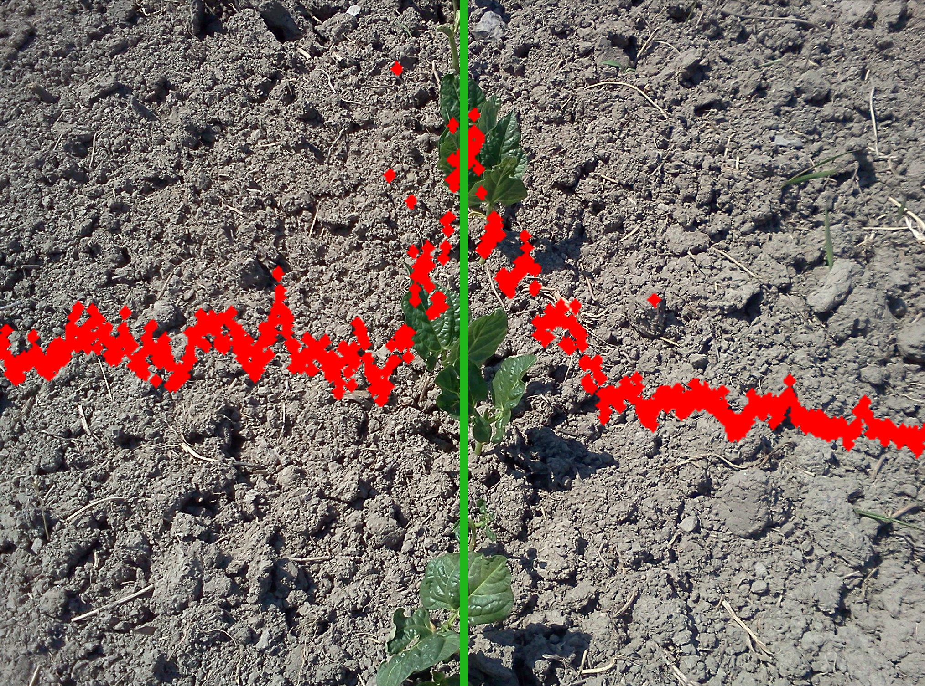

Figure 7. Row estimation by histogram thresholding.

## Electro-Hydraulic Control

Steering actuation of the cultivator was achieved via two 0.75 m stabilizers mounted 1.65 m behind the cultivator tool-bar and spaced 1.48 m apart. The hydraulic actuation of the stabilizers had a ±75° angular range of motion and a max angular velocity of 22 deg/s. The two stabilizers were actuated via a bang-bang hydraulic solenoid controller. Control of the hydraulic system is driven by the voltage differential between the feedback signal from the row detection system, i.e. the guiding rods or computer-vision module, and a rotary potentiometer mounted to the active mechanism of the hitch.

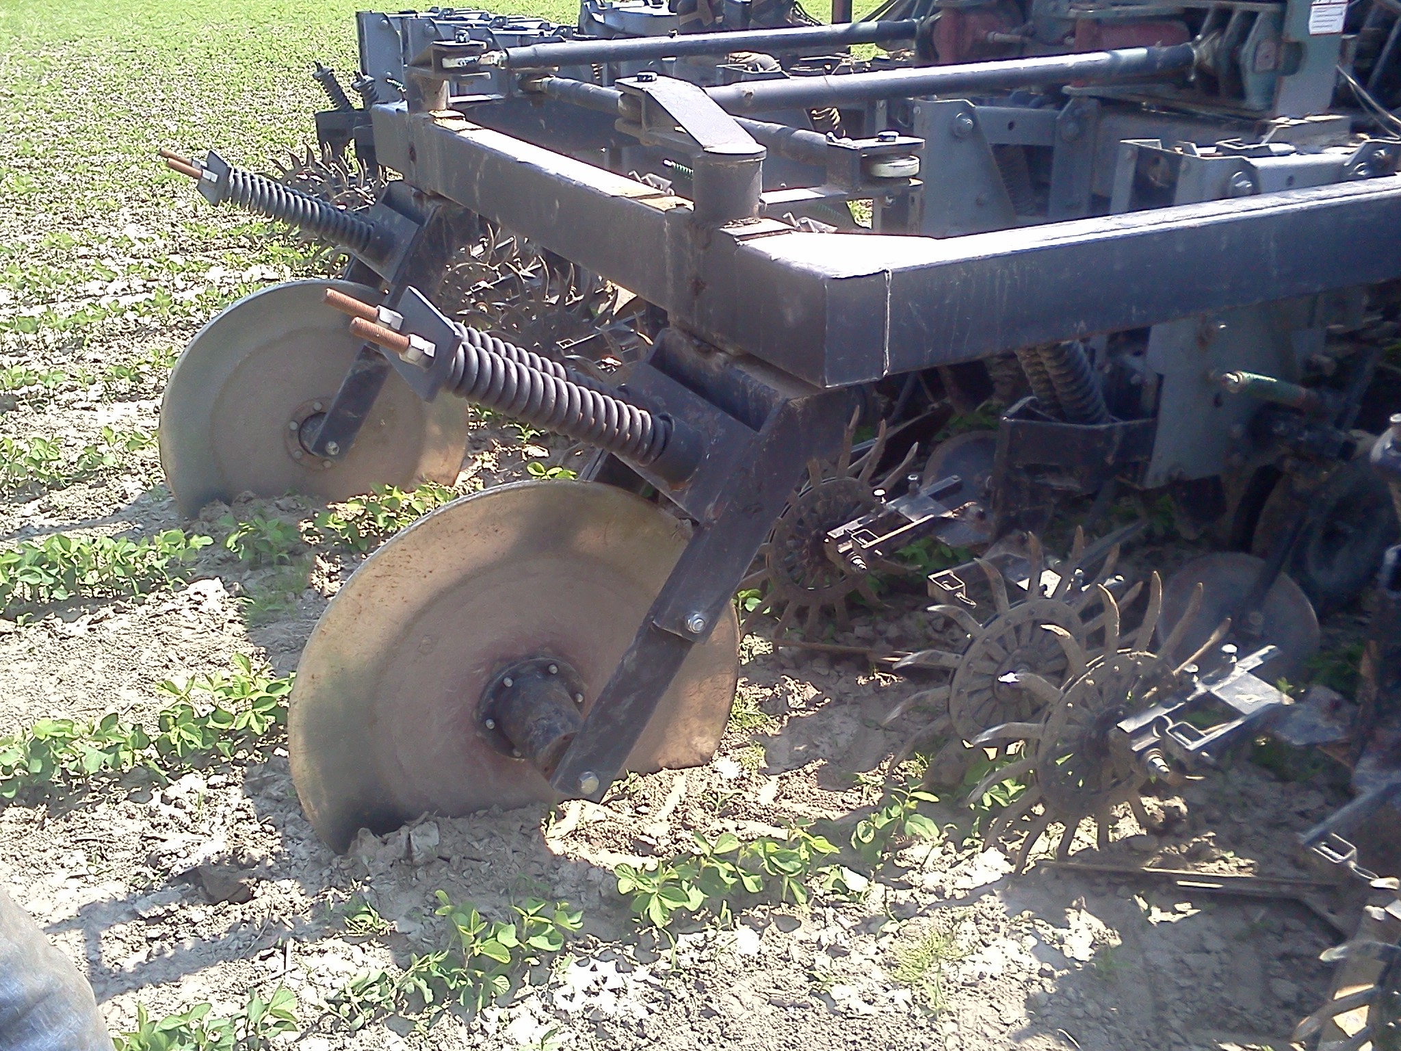

Figure 8. Rotating stabilizers.

For the computer-system control signal, signal conditioning was implemented based on a Proportional-Integral-Derivative (PID) feed-back controller. Coefficients were initially chosen to provide similar response to that of the guiding rods and were subsequently modified by trial and error.

 (12)

where KP = 1.0, KI = 4.0, KD = 0.5, N=16 is the number of integral samples, M=8 is the number of differential samples.

The output value was transmitted via a weatherproof (IP68) USB connection to an ATMEL microcontroller which was interfaced with the hydraulic solenoid controller. The microcontroller was used to generate an output signal via pulse-width modulation (PWM) operating at 490 Hz to produce a 0.0 - 5.0 VDC output signal. The microcontroller was interfaced as a serial peripheral and was controlled via serial commands at a rate of 16 Hz. The operating range of the Sukup Auto-Guide system was observed to vary from 0.10 V to 8.0 V with a fixed supply voltage of 9.70 V. Therefore, the output voltage for a given bit value can be calculated with the following conversion:

 (13)

 (14)

where Vmin = 0.10, Vmax = 8.00, VHV = 9.70, VLV = 5.0

To account for the voltage discrepancy between the two systems, the PWM output signal from the computer-vision subsystem was passed through a MOSFET logic level converter circuit to scale and shift the PWM signal to the required range:

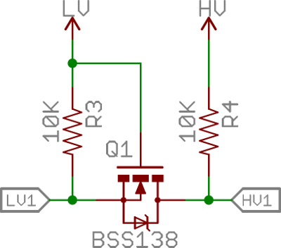

Figure 9. MOSFET logic level converter circuit.

This circuit configuration allows the system to output a voltage using PWM to systems with different voltage requirements. However, the Sukup Auto-Guide is an analog controller and many hitch data-acquisition systems are not intended for reading digital PWM signals. In the event of interfacing with a digital hydraulic controller which does not support a PWM input signal, a simple low-pass smoothing filter may be implemented using resistance and capacitor values of 3.9 kΩ and 4.7 μF, respectively. This configuration produces a time constant (τ) of 0.039 seconds and is therefore appropriate for a PWM microcontroller which updates at 10 ~ 20 Hz and operates on 5.0 VDC.

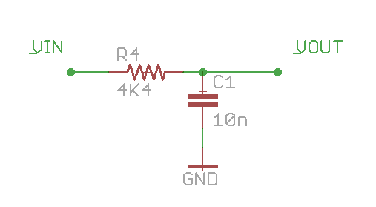

Figure 10. Low-pass filter for PWM-to-analog signal conditioning.

## Calibration

At the beginning of each set of field trials, the following camera calibration procedure was conducted to ensure proper alignment of the cameras: (1) the cultivator was aligned with the crop rows which was verified by measurements with a tape measure at the working tools; (2) lateral adjustments were made to the camera bracket to ensure the vertical center-line of each camera was aligned with the crop row; (3) vertical adjustments made to the camera bracket to ensure a subject depth of 1.0 m when measured in a direct line-of-sight from the camera lens to the soil surface. In addition to setup of the camera bracket, all tractor hydraulics were set to their default settings. The hydraulic controller settings were adjusted via the Sukup Auto-Guide's user control panel which provided sensitivity and tracking adjustment inputs. The sensitivity adjustment mapped the output range between the sensor voltage and radial resolution of the stabilizers, with a range of 1 to 10 resulting in a linear relationship from 7.7 deg/V to 18.8 deg/V, respectively. Similarly, the tracking adjustment offset the zero position of the stabilizers, with a scale of -3 to +3 corresponding to -25° to +25°, respectively. Therefore, at the beginning of each set of trials the following settings were ensured: (1) the sensitivity was set to 10 out of 10, and (2) the tracking adjustment was set to 0.

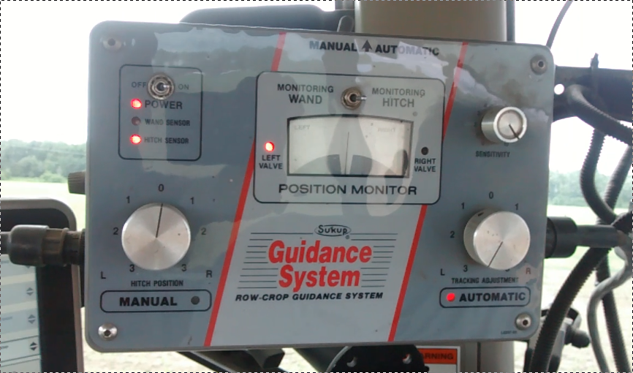

Figure 11. Hitch control module for the Sukup Auto-Guide system.

## Field Trials

Field tests of the system took place over the summer of 2014 from June to August on straight-drilled corn and soybean crops. Only organic cultivars were considered for this study, therefore no pesticides were applied to the fields and weeds were present during testing. All fields used during testing were maintained by Agri-Fusion 2000 Inc., a 4000 ha organic farming operation in St-Polycarpe, Quebec. Trials were classified into by crop type and height. For each run, five representative locations along the row were selected and the height of the crop from the soil surface was observed using a tape measure and the resulting average was used to determine the height classification of the trial using 5 cm groupings, e.g. 0 - 5 cm and 5 - 10 cm. To determine the reliability of the two systems at differing speeds of operation, trials were conducted at four approximate travel speeds: 6, 8, 10, and 12 km/h.

Each run consisted of a single-pass across the field from headland to headland. Prior to each run, the tractor and cultivator implement were aligned with the crop row. Once aligned, either the computer-vision or guiding rod system was connected as input to the hydraulic controller. Once active, the system logger was started, the tractor was engaged, and the travel speed was set via the automatic speed controller of the vehicle. Throughout each trial the following data was logged to file: (1) the lateral error estimated by the computer-vision system, (2) GPS coordinates, (3) PWM voltage output, (4) time which the image was captured to within 1 ms. During all trials, the tractor was manually operator by a professional driver without the aid of auto-steering. Due to restrictions with respect to crop health and accepted cultivation practices, some combinations of crop stage and travel speed were not tested extensively, e.g. 12 km/h was not tested at the < 10 cm height stage due to the excessively high chance of damaging the seedlings.

# Results

Table 1. Summary of all trials.

|  |  |  |  |  |  |
| --- | --- | --- | --- | --- | --- |
| Treatment | Crop Stage | Travel Speed (km/h) | Duration (s) | RMSE (cm) | 95th Percentile (cm) |
| Computer Vision (CV) | Corn (>10 cm) | 6 | 55 | 1.7 | 3.0 |
|  |  | 8 | 81 | 4.3 | 5.2 |
|  |  | 8 | 112 | 1.5 | 3.0 |
|  |  | 8 | 140 | 1.9 | 3.6 |
|  |  | 10 | 189 | 1.7 | 3.4 |
|  |  | 10 | 225 | 1.7 | 3.0 |
|  |  | 12 | 193 | 2.2 | 4.0 |
|  | Soy (<10 cm) | 6 | 334 | 0.5 | 0.6 |
|  |  | 6 | 149 | 0.9 | 1.2 |
|  |  | 6 | 431 | 0.6 | 1.0 |
|  |  | 6 | 476 | 1.5 | 2.6 |
|  |  | 6 | 375 | 1.3 | 2.5 |
|  |  | 6 | 71 | 1.7 | 3.8 |
|  |  | 8 | 80 | 2.1 | 4.0 |
|  |  | 10 | 61 | 2.1 | 3.8 |
|  |  | 10 | 50 | 1.4 | 2.4 |
|  | Soy (10 - 15 cm) | 6 | 313 | 1.0 | 1.8 |
|  |  | 8 | 360 | 1.8 | 2.8 |
|  |  | 8 | 313 | 1.6 | 2.8 |
|  |  | 8 | 139 | 3.6 | 7.0 |
|  |  | 10 | 380 | 1.5 | 3.0 |
|  |  | 12 | 418 | 1.7 | 2.8 |
|  | Soy (>15 cm) | 8 | 437 | 2.5 | 3.4 |
|  |  | 10 | 360 | 2.1 | 3.0 |
|  |  | 12 | 353 | 1.7 | 3.0 |
|  |  | 12 | 98 | 2.5 | 3.6 |
|  |  | 12 | 298 | 2.8 | 5.4 |
|  |  | 12 | 205 | 1.9 | 3.4 |
| Guiding Rods (GR) | Corn (>10 cm) | 6 | 167 | 1.6 | 3.0 |
|  |  | 6 | 338 | 3.7 | 6.8 |
|  |  | 8 | 195 | 2.0 | 3.8 |
|  |  | 8 | 211 | 1.7 | 3.0 |
|  |  | 10 | 274 | 2.0 | 3.8 |
|  |  | 12 | 128 | 2.3 | 4.4 |
|  | Soy (<10 cm) | 8 | 84 | 3.4 | 7.0 |
|  |  | 6 | 58 | 2.6 | 4.6 |
|  |  | 8 | 84 | 3.5 | 5.6 |
|  |  | 6 | 76 | 3.5 | 6.6 |
|  |  | 10 | 101 | 5.0 | 10.2 |
|  | Soy (10 - 15 cm) | 8 | 140 | 3.2 | 5.8 |
|  |  | 8 | 100 | 4.2 | 7.0 |
|  |  | 10 | 145 | 2.9 | 6.0 |
|  |  | 10 | 138 | 4.6 | 8.4 |
|  |  | 12 | 96 | 5.0 | 9.8 |
|  | Soy (>15 cm) | 6 | 556 | 2.0 | 4.0 |
|  |  | 6 | 625 | 1.0 | 2.4 |
|  |  | 10 | 344 | 1.5 | 2.4 |
|  |  | 10 | 156 | 1.3 | 2.8 |
|  |  | 12 | 107 | 1.7 | 3.0 |
|  |  | 12 | 146 | 2.8 | 6.2 |
|  |  | 12 | 104 | 1.4 | 2.6 |
|  |  | 12 | 153 | 1.9 | 3.0 |

Table 2. RMSE and 95th Percentile with respect to crop stage.

|  |  |  |  |  |  |  |  |  |
| --- | --- | --- | --- | --- | --- | --- | --- | --- |
|  | RMSE (cm) | | | | 95th Percentile (cm) | | | |
| Treatment | Soy  (<10 cm) | Soy  (10 - 15 cm) | Soy  (>15 cm) | Corn  (>10 cm) | Soy  (<10 cm) | Soy  (10 - 15 cm) | Soy  (>15 cm) | Corn  (>10 cm) |
| CV | 1.36 | 1.87 | 2.22 | 2.15 | 2.43 | 3.37 | 3.63 | 3.60 |
| GR | 3.61 | 3.98 | 1.70 | 2.22 | 6.80 | 7.40 | 3.30 | 4.13 |

Table 3. Pair-wise t-test of 95th percentiles.

|  |  |  |  |  |  |  |  |  |  |  |
| --- | --- | --- | --- | --- | --- | --- | --- | --- | --- | --- |
|  |  | CV | | | GR | | |  | | |
| Crop | Stage (cm) | Mean (cm) | Std error (cm) | Trials | Mean (cm) | Std error (cm) | Trials | t-value | df | p-value |
| Soy | < 10 | 2.87 | 1.08 | 7 | 6.8 | 2.12 | 5 | -3.818 | 4 | 0.009* |
| Soy | 10 - 15 | 3.37 | 1.83 | 6 | 7.4 | 1.69 | 5 | -3.793 | 4 | 0.010* |
| Soy | > 15 | 3.63 | 0.90 | 6 | 3.3 | 1.28 | 8 | 0.573 | 5 | 0.297 |
| Corn | > 10 | 3.60 | 0.80 | 7 | 4.1 | 1.41 | 6 | -0.819 | 5 | 0.225 |

* significant at a confidence of α = 0.05

Table 4. Tukey multiple comparison of 95th percentiles irrespective of crop type.

|  |  |  |  |  |  |  |  |
| --- | --- | --- | --- | --- | --- | --- | --- |
|  | Group 1 | | Group 2 | |  |  |  |
|  | Treatment | Stage (cm) | Treatment | Stage (cm) | Mean diff. (cm) | Std error (cm) | p-value |
| CV vs. CV | CV | < 10 | CV | 10 - 15 | 0.78 | 0.30 | 0.454 |
| CV | < 10 | CV | > 15 | 0.72 | 0.28 | 0.459 |
| CV | 10 - 15 | CV | > 15 | -0.06 | 0.29 | 0.900 |
| CV vs. GR | CV | < 10 | GR | < 10 | 2.26 | 0.34 | 0.001* |
| CV | < 10 | GR | 10 - 15 | 1.81 | 0.30 | 0.001* |
| CV | < 10 | GR | > 15 | 0.62 | 0.28 | 0.603 |
| CV | 10 - 15 | GR | < 10 | 1.48 | 0.35 | 0.052 |
| CV | 10 - 15 | GR | 10 - 15 | 1.03 | 0.31 | 0.197† |
| CV | 10 - 15 | GR | > 15 | -0.16 | 0.29 | 0.900 |
| CV | > 15 | GR | < 10 | 1.54 | 0.33 | 0.024* |
| CV | > 15 | GR | 10 - 15 | 1.09 | 0.29 | 0.100 |
| CV | > 15 | GR | > 15 | -0.10 | 0.26 | 0.900 |
| GR vs. GR | GR | < 10 | GR | 10 - 15 | -0.45 | 0.35 | 0.900 |
| GR | < 10 | GR | > 15 | -1.64 | 0.33 | 0.014* |
| GR | 10 - 15 | GR | > 15 | -1.19 | 0.29 | 0.057 |

* significant at a confidence of α = 0.05

† not significant when classified by crop height only

# Discussion

With respect to RMSE, both methods for row detection performed comparatively, with a average RMSE of 2.88 cm and 1.90 cm of all trials for the computer-vision and guiding rod systems, respectively (Table 2). However, the error within a given trial can be said to be non-parametric, therefore the 95th percentile should be considered a more reliable metric of the system performance than RMSE. With respect to the 95th percentile, the guiding rods demonstrated significantly greater error than the computer-vision system for the < 10 cm and 10 - 15 cm crop stages of soy (Table 2). However, when disregarding crop species and grouping trials by height alone, the computer-vision and guiding rod methods no longer showed a significant difference at the 10 - 15 cm crop (Table 4). Accuracy of the guiding rods increased dramatically as the plants matured, resulting in a significant decline in both 95th percentile and RMSE (Table 2). Conversely, the computer-vision system demonstrated a slight increase in 95th percentile error with increasing crop height, which was possibly attributable to either the greater crop foliage area reducing the precision of row centroid estimation. However, the correlation between crop height and 95th percentile of the computer-vision system was determined to not be statistically significant (Table 4).



Figure 12. 95th percentile error of trials with respect to travel speed.

Linear regression of 95th percentile values revealed that the performance of the guiding rod system decreased as a function of travel speed for the <10 cm and 10 - 15 cm stages (Figure 12). Conversely, the guiding rods did not exhibit a same effect and showed no significant correlation between 95th percentile and travel speed. These results suggest that when using guiding rods for cultivation on underdeveloped crops it is necessary to reduce the speed of cultivation in order to maintain a 95th percentile error of less than 6.0 cm, which is considered acceptable guidance precision in most circumstances. The positive correlation between 95th percentile error and travel speed is attributable to the increased probability of the guiding rods losing the crop row when traveling at speeds in excess of 8 km/h. Due to the mechanical action of row estimation via guiding rods, higher speed cultivation causes the rods to exert greater force on underdeveloped plants, thus resulting in poor tracking and damage to the seedlings. Therefore, it can be asserted that the computer-vision method for row detection is a more robust solution than mechanical guiding rods with respect to early season cultivation.

## Future Improvements

Due to the fact that the cameras used for this study were intended for security applications, the cameras were designed for usage in a wide range of ambient lighting. Specifically, the photosensor of the cameras was sensitive to infrared (IR) light and featured a built-in array of 24 IR LEDs. Although this feature theoretically extended the daily hours of operation, IR-sensitivity proved to have a negative affect on color-quality under intense ambient light, i.e. >20000 Lux, resulting in over-exposure and blue-shifting of green tones in the HSV color-space. To correct for this effect, applying contrast-limited adaptive histogram equalization (CLAHE) as a pre-processing technique prior to the BPPD filter may reduce the negative affects of IR-sensitivity without requiring hardware changes such as IR insensitive cameras or IR-filtering lenses.

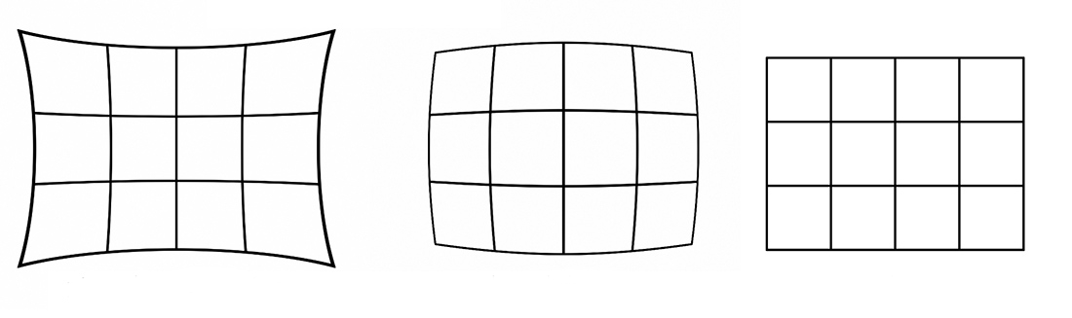

Figure 13. Illustration of radial lens distortion of image.

For this study, row offsets were determined by analyzing the plant foliage mask in the direction of travel with a relatively small subject distance and cameras mounted at low-oblique perspective (Figure 2). Due to the low-oblique angle of inclination, very short subject depth, and orthogonal method for row estimation, this study did not implement tangential or radial distortion correction. However, for alternate usage cases, e.g. cameras aligned at the mid-point between rows or at subject depths greater than 1.0 m, it would be necessary for tangential and radial distortion correction to be implemented. Due to the variable nature of how computer-vision row detection systems are installed, a versatile method for in-field camera calibration demonstrated by Lee et al. in 2009 may be well suited to. This method utilizes a checkerboard pattern which is placed in the camera’s field of view. An image is captured and the positions of the corners are identified. Using the known size of the squares, the tangential and radial distortion coefficients (Pn and Kn, respectively) can be determined empirically. Once the distortion coefficients are known, each newly captured image can be rectilinearized using the Brown-Conrady model of distortion correction (Brown, 1966):

 (15)

where (xd,yd) is the distorted image point as project on image plane using lens, (xu,yu) undistorted image point project by ideal pin-hole camera, (xc,yc) is the distortion center, Kn nth radial distortion coefficient, Pn is the nth tangential distortion coefficient.

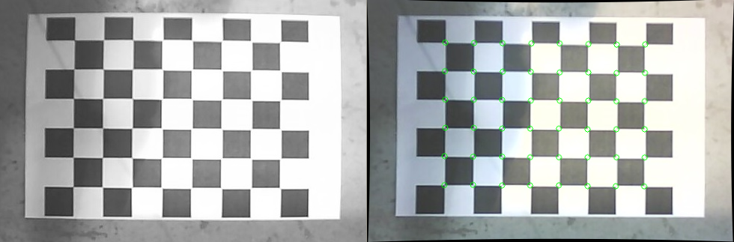

Figure 14. Distortion correction of camera using the checkerboard technique.

With respect to the hydraulic steering system, this study was restricted to a rotating stabilizer implement guidance system and therefore the orientation of the crop rows relative to the cultivator (and by extension the cameras) was effectively orthogonal. As such, the proposed method for row detection using histogram analysis in the direction of travel is appropriate for both rotating stabilizer and center-shift steering systems. However several commercially available hydraulic steering system designs make use of pivoting hitch systems. In pivoting hitch systems, the cultivator toolbar is rotated about a central pivot-point to produce lateral adjustment force on fixed cultivator discs.

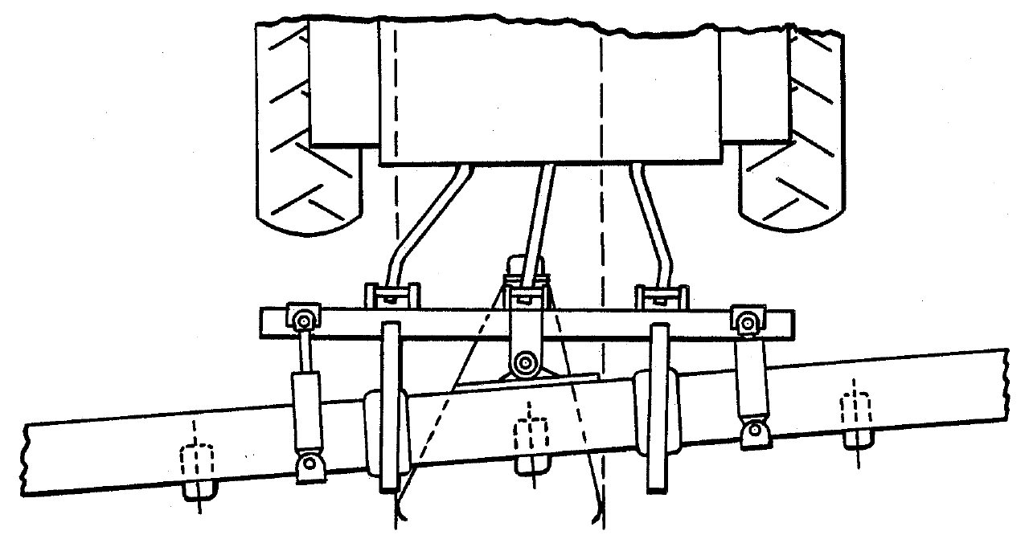

Figure 15. Pivoting hitch hydraulic steering system (Fleischer, 1990)

Pivoting hitch steering systems may rotate the cultivator toolbar as much as ±5 degrees (Figure 15). This pivoting action effectively changes the apparent offset of the crop row and therefore significantly reduces the accuracy of row estimation using the method proposed in this paper. To compensate for this effect, knowledge of the camera's position relative to the pivot point is required as well as the camera's instantaneous orientation relative to the direction of travel. Although the hitch's angle of orientation may be determined via sensor feedback from the hitch itself (e.g. via a rotary encoder), an alternate approach using computer-vision is an attractive option. Methods such the Hough Line Transform or feature-based motion estimation of the images (i.e. keypoint tracking) may prove to be robust solutions which do not require integration with the hitch controller and would therefore be system-agnostic. Assuming that the velocity of the implement in the direction of the crop row (Vy) is much greater than the rate of lateral adjustment (Vx), the instantaneous error of the camera's centroid relative to the true position of the crop row can be calculated with the following equation:

 (16)

where x0 is the lateral distance from the camera to the pivot point, y0 is the longitudinal distance from the camera to the pivot point, and θ is the instantaneous orientation of the camera relative to the direction of travel.



Figure 16. Two computer-vision trials conducted on different fields, 10 - 15 cm soy at 8 km/h.

Due to the nature of disc-steer cultivator guidance, such a system has several uncontrollable variables which can have a detrimental effects on performance, e.g. soil conditions, terrain slope, tractor precision, and travel speed. These external factors are dynamic, change significantly during field operations, and ultimately impact the overall performance of the system. As can be seen in Figure 15, two trials conducted on the same crop and travel speed but on different fields demonstrated noticeably different behaviors, specifically with respect to bias and response time. To account for the non-linearity and variability inherent to implement guidance, the application of dynamic learning algorithms is a viable solution which will reduce the need for regular human intervention and additional sensors on implements (e.g. fifth wheels or tilt-sensors). Reinforcement learning techniques, such as Q-learning, are well suited to this style of control system and have produced successful results for robotics and automotive applications with variable load requirements, such as DC motor control (Aziz, 2015) and active suspension systems (Chiou, 2012). The Q-learning algorithm is primarily intended for applications with non-calibrated control of non-linear, multiple-input, multiple-output systems. Q-learning is based on the principal that for a given action, the resulting behavior of a system can be classified and subsequently rewarded or penalized. A particularly interesting subset of real-time learning algorithms have been proposed for integration as adaptive PID control systems known as Fuzzy PID (FPID) controllers, which utilize fuzzy membership to classify the behavior of the system (Boubertakh, 2010). Unlike a classical PID controller, the coefficients of an FPID controller are tuned over time, often via a reinforcement learning reward mechanism. Actions which result in positive behavior for a given state of the system (e.g. adjusting gain offsets due to bias) are incentivized and those which resulted in negative behavior (e.g. high gains resulting in overshooting) are penalized. Ultimately, the learning process produces a non-linear response matrix which adapts to the current working environment of the system. Applications of adaptive PID controllers in implement guidance have potential to improve performance consistency and remove the need for complex of system calibration when working with varying implements and tool configurations.

# Conclusion

The BPPD method proved to be effective in various lighting conditions and crop conditions. The computer-vision system significantly outperformed the guiding rods at the earliest stages of growth, i.e. soy <10 cm and 10 - 15 cm. However, at the later stages of growth, soy >15 cm and corn >10 cm, there was no significant difference in performance between the two guidance systems. Thus the camera system can provide farmers improved functionality during vital early-season cultivation.

## Acknowledgements

This study was supported in part by funding provided through the National Science and Engineering Research of Canada (NSERC) Engage program with assistance from Jean Cantin of the Quebec Ministry of Agriculture, Fisheries and Food (MAPAQ).

References

Aziz, K. A., El-Bardini, M., & El-Rabaie, N. M. (2015). Embedded Adaptive Fuzzy Controller Based on Reinforcement Learning for DC Motor with Flexible Shaft. *Arabian Journal for Science and Engineering*, 40(8), 2389-2406.

Boubertakh, H., Tadjine, M. Glorennec, P.Y., & Labiod, S. (2010). Tuning fuzzy PD and PI controllers using reinforcement learning. *ISA Transactions*, 49(4), 543-551.

Brivot, R., & Marchant, J. A. (1996). Segmentation of plants and weeds for a precision crop protection robot using infrared images. IEE Proceedings-Vision, Image and Signal Processing, 143(2), 118-124.

Brown, Duane C. (1966). Decentering distortion of lenses. Photogrammetric Engineering, 32 (3), 444–462.

Chiou, J.S., Tsai, S.H. & Lui, M.T. (2012). A PSO-based adaptive fuzzy PID-controller. Simulation Modeling Practice and Theory, 26, 49-59.

Guijarro, M., Pajares, G., Riomoros, I., Herrera, P. J., Burgos-Artizzu, X. P., & Ribeiro, A. (2011). Automatic segmentation of relevant textures in agricultural images. *Computers and Electronics in Agriculture*, *75*(1), 75-83.

Hague, T., & Tillett, N. D. (2001). A bandpass filter-based approach to crop row location and tracking. *Mechatronics*, *11*(1), 1-12.

Hague, T., Tillett, N. D., & Wheeler, H. (2006). Automated crop and weed monitoring in widely spaced cereals. *Precision Agriculture*, *7*(1), 21-32.

Kise, M., Zhang, Q., & Más, F. R. (2005). A stereovision-based crop row detection method for tractor-automated guidance. *Biosystems Engineering*, *90*(4), 357-367.

Kocher, M. F., Smith, M. B., Grisso, R. D., & Bashford, L. L. (2000). Performance tests of three-point mounted implement guidance systems: I. Procedure. *Biological Systems Engineering: Papers and Publications*, 169.

Lee, S. H., Lee, S. K., & Choi, J. S. (2009). Correction of radial distortion using a planar checkerboard pattern and its image. *Consumer Electronics, IEEE Transactions on*, *55*(1), 27-33.

Meyer, G. E., Mehta, T., Kocher, M. F., Mortensen, D. A., & Samal, A. (1998). Textural imaging and discriminant analysis for distinguishing weeds for spot spraying. *Transactions of the ASAE*, *41*(4), 1189-1197.

Meyer, G. E., & Neto, J. C. (2008). Verification of color vegetation indices for automated crop imaging applications. *Computers and Electronics in Agriculture*, *63*(2), 282-293.

Parvathi, K. M., Moorthy, S., Boigelot, B., & Mercatoris, B. (2015). Effective segmentation of green vegetation for resource-constrained real-time applications.

Olsen, H. J. (1995). Determination of row position in small-grain crops by analysis of video images. *Computers and electronics in agriculture*, *12*(2), 147-162.

Pla, F., Sanchiz, J. M., Marchant, J. A., & Brivot, R. (1997). Building perspective models to guide a row crop navigation vehicle. *Image and vision computing*, *15*(6), 465-473.

Robati, J., Navid, H., Rezaei, M., & Ghiasi, A. R. (2012). Automatic Guidance of an Agricultural Tractor along with the Side Shift Control of the Attached Row Crop Cultivator. *Journal of Agricultural Science and Technology B*, *2*(1), 151-158.

Rovira-Más, F., Zhang, Q., Reid, J. F., & Will, J. D. (2005). Hough-transform-based vision algorithm for crop row detection of an automated agricultural vehicle. *Proceedings of the Institution of Mechanical Engineers, Part D: Journal of Automobile Engineering*, *219*(8), 999-1010.

Slaughter, D. C., Chen, P., & Curley, R. G. (1999). Vision guided precision cultivation. *Precision Agriculture*, *1*(2), 199-217.

Slaughter, D. C., Giles, D. K., Fennimore, S. A., & Smith, R. F. (2008). Multispectral machine vision identification of lettuce and weed seedlings for automated weed control. *Weed Technology*, *22*(2), 378-384.

Tian, L. F., & Slaughter, D. C. (1998). Environmentally adaptive segmentation algorithm for outdoor image segmentation. *Computers and Electronics in Agriculture*, *21*(3), 153-168.

Tillett, N. D. (1991). Automatic guidance sensors for agricultural field machines: a review. *Journal of agricultural engineering research*, *50*, 167-187.

Tillett, N. D., Hague, T., & Miles, S. J. (2002). Inter-row vision guidance for mechanical weed control in sugar beet. *Computers and Electronics in Agriculture*, *33*(3), 163-177.

Woebbecke, D. M., Meyer, G. E., Von Bargen, K., & Mortensen, D. A. (1995). Color indices for weed identification under various soil, residue, and lighting conditions. *Transactions of the ASAE*, *38*(1), 259-269.

Wolf, P. R. & Dewitt, B. A. (2000). *Elements of Photogrammetry: with applications in GIS* (Vol. 3). New York: McGraw-Hill.

Zheng, L., Zhang, J., & Wang, Q. (2009). Mean-shift-based color segmentation of images containing green vegetation. *Computers and Electronics in Agriculture*, *65*(1), 93-98.